# CALCULATING FAMILY EXPENSES USING SERVICE NOW

**NAAN MUDALVAN PROJECT TEAM ID: NM2025TMID17813**

**Team Leader: JEBICKSON SAMUEL.J**

**Team Member : DHANUSH.S**

**Team Member: DINESH KUMAR.A**

**Team Member: KISHORE KUMAR.D**

# ST.JOSEPH’S COLLEGE (ARTS & SCIENCE)

**INDEX**

1. Introduction
2. Abstract
3. Problem statement
4. Solution
5. Practical use
6. Knowledge gained
7. Milestone 1:Setting up servicenow instance
8. Milestone 2:Creation of new update set
9. Milestone 3:Creation of table family expenses 10.Milestone 4: Creation of table daily expenses 11.Milestone 5: Creation of relationship
10. Milestone 6:Configuring Related list on family expenses
11. Milestone7:CreationofBusinessrules 14.Milestone8:Configuretherelationship 15.Conclusion

# INTRODUCTION

Managing family expenses is one of the most important aspects of financial planning, yet it is often overlooked or handled in unstructured ways like handwritten notes or spreadsheets. Families frequently face challenges such as overspending, lack of budget control, and difficulty in analyzingwheretheirmoneygoes.Toaddresstheseissues, technology can play a vital role by providing structured, automated, and user-friendly solutions.

This project, “Calculating Family Expenses Using ServiceNow,”aimstocreateadigitalsystemthathelpstrack, categorize, and manage family expenses efficiently.

ServiceNow, known for its robust workflow automation and application development capabilities, provides an excellent platform for building such a system. By leveraging ServiceNow,thisprojecttransformsexpensemanagementinto a more streamlined process with features like expense categorization, daily tracking, budget limits, reporting, and automated business rules.

The system will not only simplify financial management for families but also provide real-time insights into spending patterns, allowing better decision-making.With its scalability and flexibility, the solution can be expanded to suit different familystructuresandevenadaptedforsmallbusinessexpense management. Ultimately, the project showcases how a powerful enterprise platform like ServiceNow can be applied beyond IT workflows to solve everyday problems in an innovative and practical way.

# ABSTRACT

Expense management plays a crucial role in maintaining financialstabilitywithinfamilies,yettraditionalmethodssuch asmanualtrackingorspreadsheetsoftenleadtoerrors,lackof visibility, and poor decision-making. To address this challenge, thisproject focusesondesigningandimplementing a Family Expense Management System using ServiceNow.

TheapplicationleveragesServiceNow’spowerfullow-code development environment to create structured tables, relationships, and automated workflows for recording and analyzing expenses. Key features include categorizing expenses(suchasfood,utilities, andtransport),maintaining family member details, linking daily transactions, and applying business rules to validate data and automate calculations. By configuring related lists and creating meaningful reports, the system provides users with a clear overview of their financial habits and budget limits.

Theproposedsolutionnotonlysimplifiesday-to-dayexpense tracking but also provides real-time insights into spending patterns, enabling families to make smarter financial decisions. Furthermore, the project demonstrates the versatility of ServiceNow beyond traditional IT service management, showcasing its potential in solving practical, real-world problems.

# PROBLEMSTATEMENT

Managing household expenses is often a difficult and time- consuming task for families. Most families rely on manual methodssuchasnotebooks,receipts,orspreadsheetstotrack their daily spending. These methods come with several challenges:

* Lack ofreal-timetracking of expenses.
* Difficultyincategorizingandconsolidatingexpenses like food, utilities, rent, and transportation.
* Limitedabilitytoanalyzespendingpatternsorgenerate reports.
* Highchancesof errorsduetomanualdataentry.
* Noautomationtoalertfamiliesaboutoverspendingor exceeding budgets.

As a result, families often lose visibility into their financial flow, making it harder to control budgets or make informed financial decisions. This creates the need for a systematic, automated,anduser-friendlysolutiontomanageandcalculate family expenses efficiently.

# SOLUTION

The proposed solution is to build a Family Expense Management SystemontheServiceNowplatform.ServiceNow,beingarobustlow- code/no-code platform, provides all the tools required to create structured applications without needing extensive programming knowledge.

Thesolutioninvolves:

* **Creatingcustomtables**tostorefamilymemberdetailsand daily expenses.
* **Definingrelationships**betweenfamilymembersandtheir respective expenses for easy tracking.
* **Configuringrelatedlists** sothatexpenseslinkedtoeachfamily member can be viewed in one place.
* **Implementingbusinessrules**toautomatecalculations,validate entries, and ensure data accuracy.
* **Generating reports and dashboards** to visualize monthly/annualspendingandhighlightbudgetdeviations.
* **Usingupdatesets**totrackandmigratecustomizations,ensuring proper version control.

# PRACTICALUSE

The Family Expense Management System built on ServiceNowhelpsfamilies track,categorize, and analyzetheir expenses in a structured way. It simplifies budgeting, reduces errors from manual tracking, and provides real-time insights into spending patterns. Families can use it to set limits, monitor monthly expenses, and generate reports for better financial decisions. Beyond households, the same system can beadaptedfor smallbusinessesto managecashflowanddaily transactions effectively, proving the versatility of ServiceNow in solving practical, non-IT problems.

# KNOWLEDGE GAINED

* Learnedhowto setup andconfigureaServiceNowdeveloper instance for building applications.
* Understoodtheimportanceofupdatesetsfortrackingand migrating customizations.
* Gainedpracticalskillsincreatingcustomtables anddefining fields to store structured data.
* Learnedhowto establishrelationships betweentablesforlinked data management.
* Practicedconfiguringrelatedlistsforeasiernavigationand record visibility.
* Understoodhowtocreateandapply businessrulesfor automation and validations.
* Gainedinsightsintodatamodelinganddatabaseconceptswithin ServiceNow.
* Learnedhowtogeneratereportsanddashboards forreal-time analysis.
* UnderstoodhowServiceNowcanbeappliedto non-ITusecases like family expense tracking.
* Improvedoverallknowledgeof workflowautomationand low- code development.

# MILESTONE1:SETTING UP THE SERVICE NOW INSTANCE

* Go to the official Service Now Developer portal: [https://developer.servicenow.com](https://developer.servicenow.com/?utm_source=chatgpt.com) and create a developer account.
* After signing in, open the Personal Developer Instance section from the dashboard.
* Select Request Instance to generate a fresh Service Now environment for development.
* Provide the necessary details(like version selection)and confirm your request.
* Wait for the confirmation email containing your instance URL and login credentials.
* Use the credentials to log into your newly created Service Now instance.
* Once inside , explore the interface and begin working on the platform.

# MILSTONE2:CREATION OF NEW UPDATE SET

* Log into your Service Now instance and go to the Application Navigator.
* Search for Update Sets and open Local Update Sets under *System Update Sets*.
* Click on New to create a fresh updateset.
* Enterthefollowing details:
  + Name:*Family Expenses*
  + Description:Updatesettocaptureallconfigurations related to the Family Expense Management project.
* SavetherecordandmarkitastheCurrentUpdateSet,so every change you make is tracked under this set.
* Verifythattheupdatesetisactivebycheckingtheheader at the top of the screen.
* From this point forward, all customizations (tables, relationships,andbusinessrules)willberecordedinside the *Family Expenses* update set.

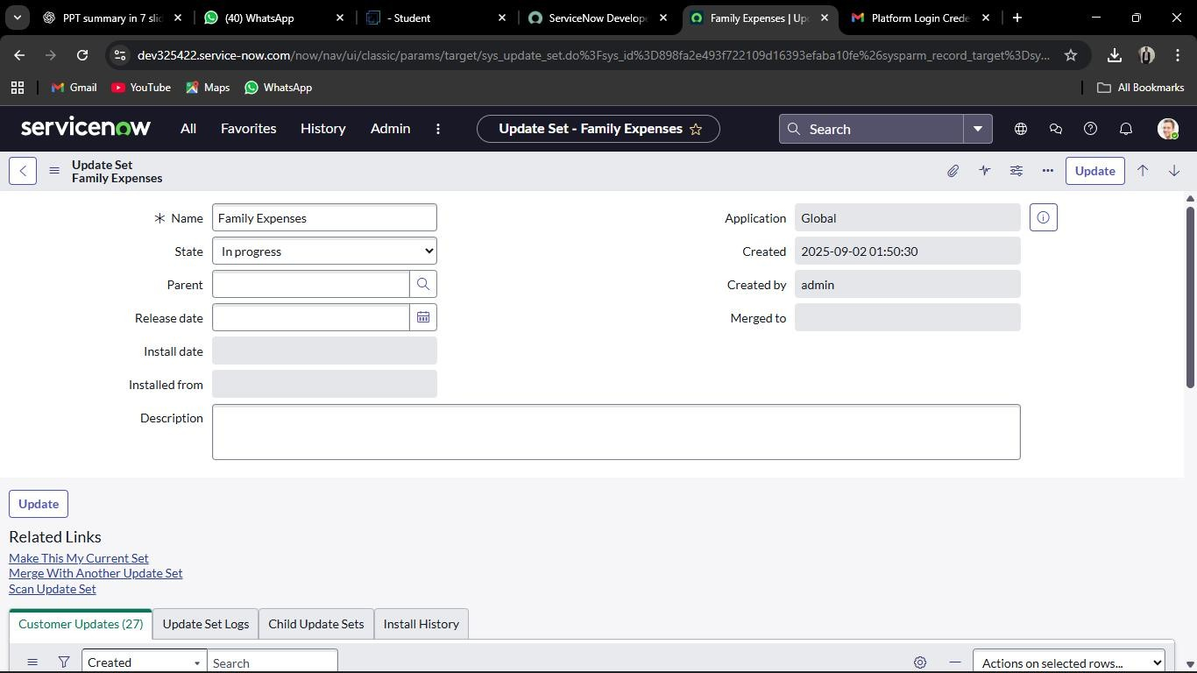

# MILSTONE3:CREATIONOFTABLEFAMILY EXPENSES

**Activity1 –CreatingtheFamilyExpensesTable**

* InyourServiceNowinstance,navigatetoAll>Tables using the filter navigator.
* Click onNewtocreateanew table.
* Fillin therequireddetails:
  + Label:*FamilyExpenses*
  + Name:(Thiswillbeauto-generatedbasedonthe label)
  + NewMenuName:*FamilyExpenditure*
* Savetherecord tocreatethenewtable.

# MILSTONE3:CREATIONOFTABLEFAMILY EXPENSES

**Activity2–AddingColumnstotheFamilyExpensesTable**

Duration:1Hour SkillTags:TableConfiguration,DataModeling,ServiceNowBasics

* OpenthenewlycreatedFamilyExpensestable.
* Toaddcolumns,double-clickneartheexistingcolumnstoinsert a new row.
* Enterthefollowingdetailsonebyone:

1. ColumnLabel:Number
   * Type:String
2. ColumnLabel:Date
   * Type:Date
3. ColumnLabel:Amount
   * Type:Integer
4. ColumnLabel:ExpenseDetails
   * Type:String
   * MaxLength:800

# MILSTONE3:CREATIONOFTABLEFAMILY EXPENSES

**Activity3–MakingtheNumberFieldanAuto-Number Open the Family Expenses table.**

* Locatethe Numberfield/columnanddouble-clicktoopenits properties.
* ScrolldownandswitchtotheAdvancedview.
* IntheDefaultValuesection:
  + Checktheboxfor*UseDynamic Default*.
  + SettheDynamicDefaultValueto*GetNextPadded Number*.
* ClickUpdatetosavethe changes.

# MILSTONE3:CREATIONOFTABLEFAMILY EXPENSES

**Activity4–ConfiguringtheForm**

* NavigatetoAll>inthefilter,searchforFamilyExpenses.
* OpentheFamilyExpensestable.
* ClickonNewtocreateanewformentry.
* Ontheformheader,right-clickandselect:
  + Configure>FormDesign.
* IntheFormDesigner,usedrag-and-dropto:
  + Rearrangefields.
  + Grouprelatedfieldstogether.
  + Addsectionsifrequiredforbetterclarity.
* Savethecustomizedformlayout.

# MILSTONE4:CREATIONOFTABLEDAILY EXPENSES

**Activity1–CreatingTheDailyExpensesTable**

* NavigatetoAll>Tablesusingthefilternavigator.
* ClickonNewtocreate anew table.
* Fillintherequireddetails:
* Label:DailyExpenses
* Name:(Auto-populatedbythesystem)
* AddModuletoMenu:*Family Expenditure*
* Gototheformheader,right-click,andselectSave.

# MILSTONE4:CREATIONOFTABLEDAILY EXPENSES

**Activity2–CreatingColumns(Fields)**

* OpentheDailyExpenses table.
* NearColumns,double-clicktoinsertanew rowandaddthefollowing fields:

1. ColumnLabel:Number
   * Type:String
2. ColumnLabel:Date
   * Type:Date
3. ColumnLabel:Expense
   * Type:Integer
4. ColumnLabel:FamilyMemberName
   * Type:Reference
   * MaxLength:800
5. ColumnLabel:Comments
   * Type:String
   * **MaxLength: 800**

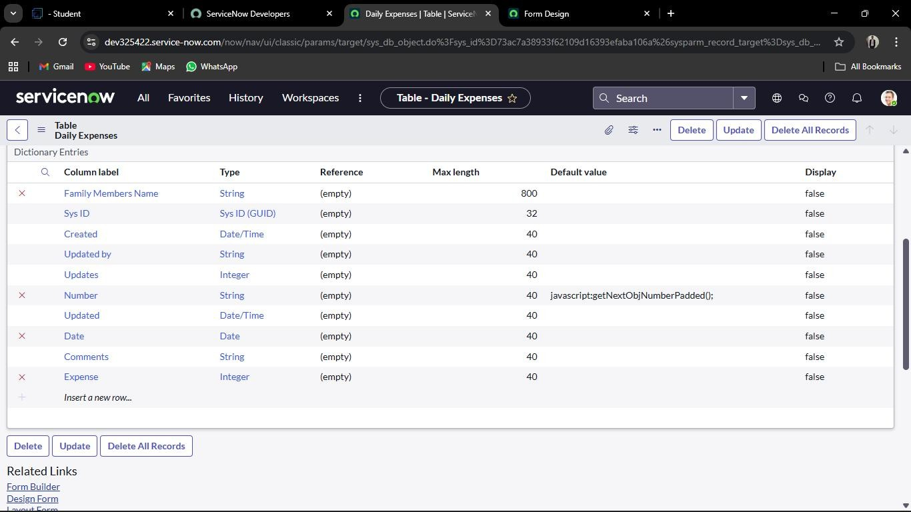

# MILSTONE4:CREATIONOFTABLEDAILY EXPENSES

**Activity3–MakingNumberFieldanAuto-Number**

* OpentheDailyExpenses table.
* LocatetheNumberfield/columnanddouble-clicktoopenitsproperties.
* ScrolldownandswitchtotheAdvancedView.
* IntheDefaultValuesection:
  + ChecktheboxforUseDynamicDefault.
  + SettheDynamicDefaultValuetoGetNextPaddedNumber.
* ClickUpdatetosavechanges. Configuring Number Maintenance:
* NavigatetoAll>NumberMaintenance.
* ClickonNew.
* Enterthedetailsasfollows:
  + Table:FamilyExpenses
  + Prefix:MFE
* Clickon Submit.

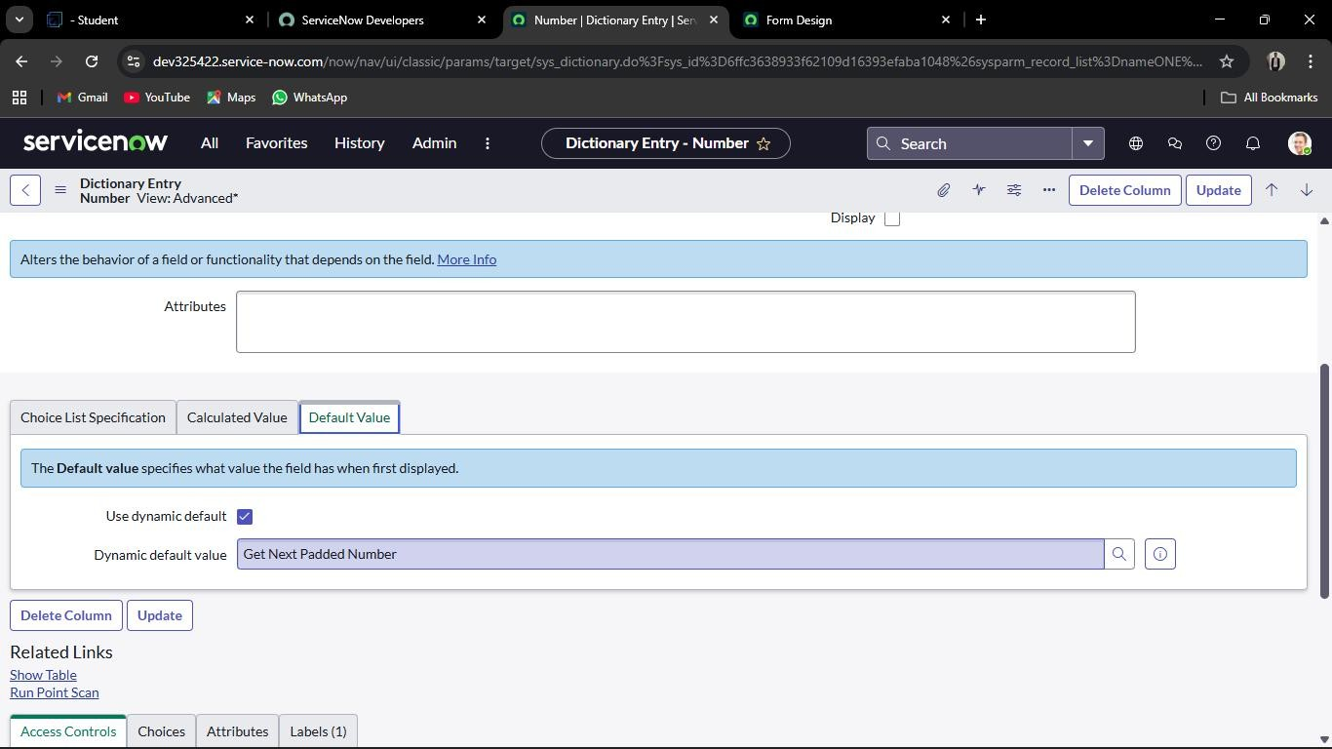

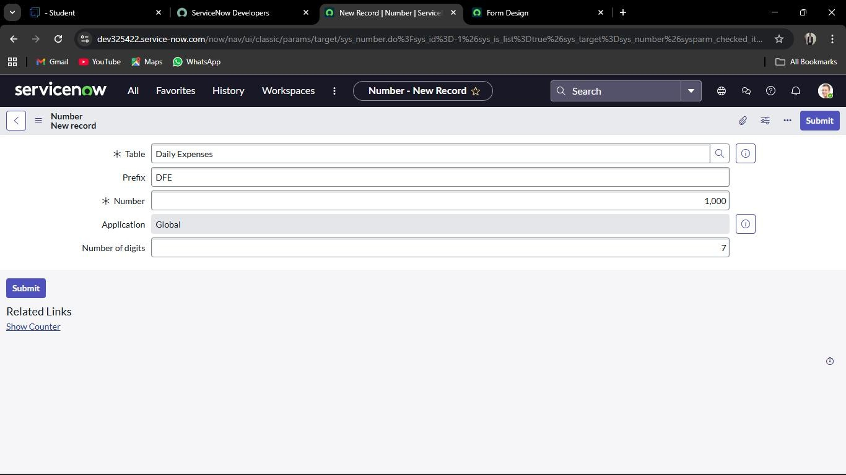

# MILSTONE4:CREATIONOFTABLEDAILY EXPENSES

**Activity4–ConfigureTheForm**

* NavigatetoAll>DailyExpensesusingthefilter.
* OpentheDailyExpensestable.
* ClickonNewtocreateanewformentry.
* Ontheformheader,right-click,thenselect:
* Configure>FormDesign.
* IntheFormDesigner,draganddropfieldstocustomizethe form layout as per requirement.
* Applythefollowingconfigurations:
* NumberField→Setas*Read-Only*byclickingthegeariconand checking Read-Only.
* DateField→Setas*Mandatory*byclickingthegeariconand checking Mandatory.
* FamilyMemberNameField →Setas*Mandatory*usingthe same method.
* ClickSavetoapplythechanges.

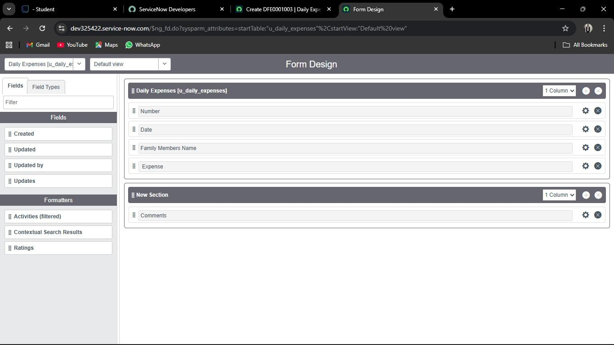

# MILSTONE5:CREATIONOFRELATIONSHIP BETWEEN FAMILYEXPENSESAND DAILY EXPENSES TABLES

* NavigatetoAll>Relationshipsusingthefilternavigator.
* ClickonNewtocreate anew relationship.
* Fillinthedetailsasfollows:
* Name:DailyExpenses
* AppliestoTable:*FamilyExpenses*
* RelatedListTable:*DailyExpenses*
* ClickSave.

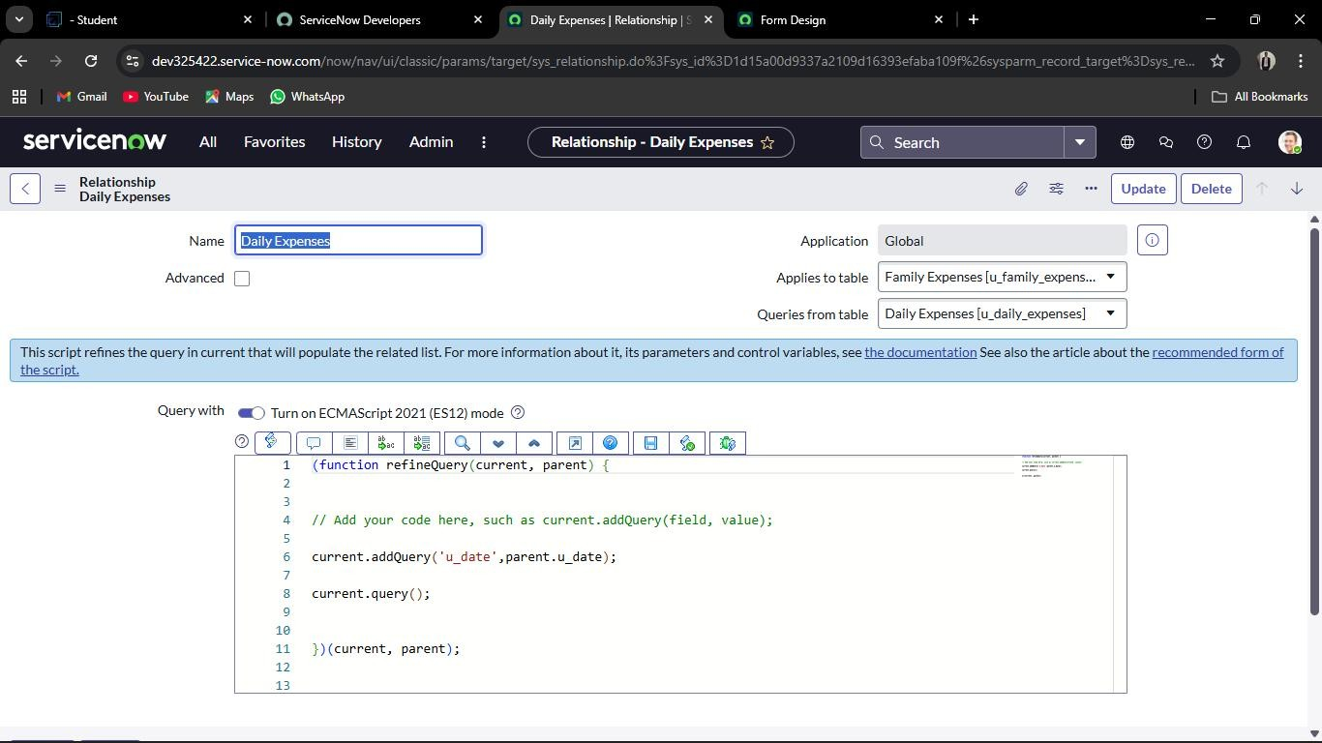

# MILSTONE6:CONFIGURINGRELATEDLIST ON FAMILY EXPENSES

* NavigatetoAll>FamilyExpensesusingthefilter.
* OpentheFamilyExpensestable.
* ClickonNewtoopentheformview.
* Ontheformheader,right-click,thenselect:
* Configure>RelatedLists.
* Fromtheavailableoptions,add DailyExpensestotheSelected Area.
* ClickSavetoapplythechanges.

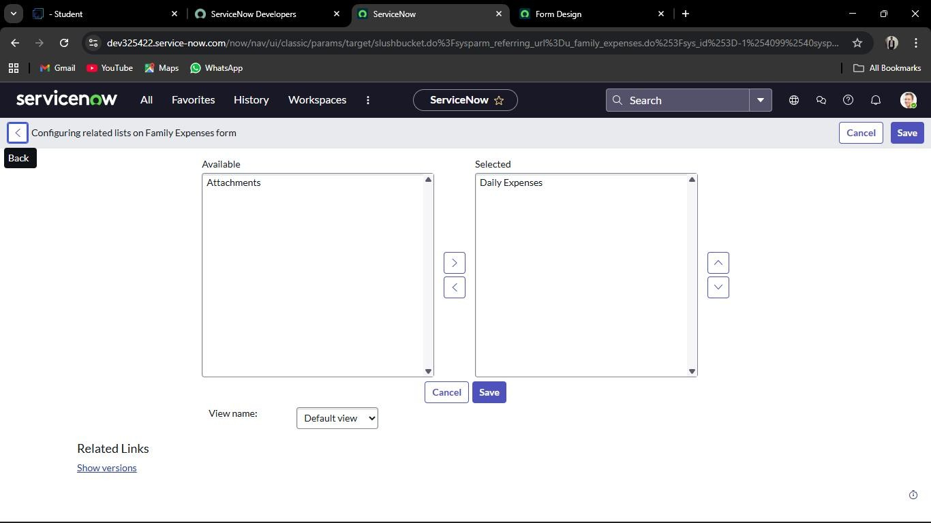

# MILSTONE7:CREATIONOFBUSINESSRULES

* NavigatetoAll>BusinessRulesusingthefilter.
* UnderSystemDefinition,selectBusinessRulesandclickNew.
* Enterthefollowingdetails:
  + Name:FamilyExpensesBR
  + Table:*DailyExpenses*
  + CheckAdvanced.
* IntheWhentorunsection,check:
  + Insert
  + Update
* IntheAdvancedtab,addthefollowingscript: (functionexecuteRule(current,previous/*nullwhenasync*/){

varFamilyExpenses=newGlideRecord('u_family_expenses'); FamilyExpenses.addQuery('u_date', current.u_date); FamilyExpenses.query();

if (FamilyExpenses.next())

{ FamilyExpenses.u_amount+=current.u_expense; FamilyExpenses.u_expense_details+=">"+current.u_comments+ ":"

+ "Rs." + current.u_expense + "/-"; FamilyExpenses.update();

}else{

varNewFamilyExpenses=newGlideRecord('u_family_expenses'); NewFamilyExpenses.u_date = current.u_date; NewFamilyExpenses.u_amount = current.u_expense; NewFamilyExpenses.u_expense_details += ">" +

current.u_comments+":"+"Rs."+current.u_expense+"/-";

NewFamilyExpenses.insert();

}

})(current,previous); Gototheformheader,right-click,thenselectSave.

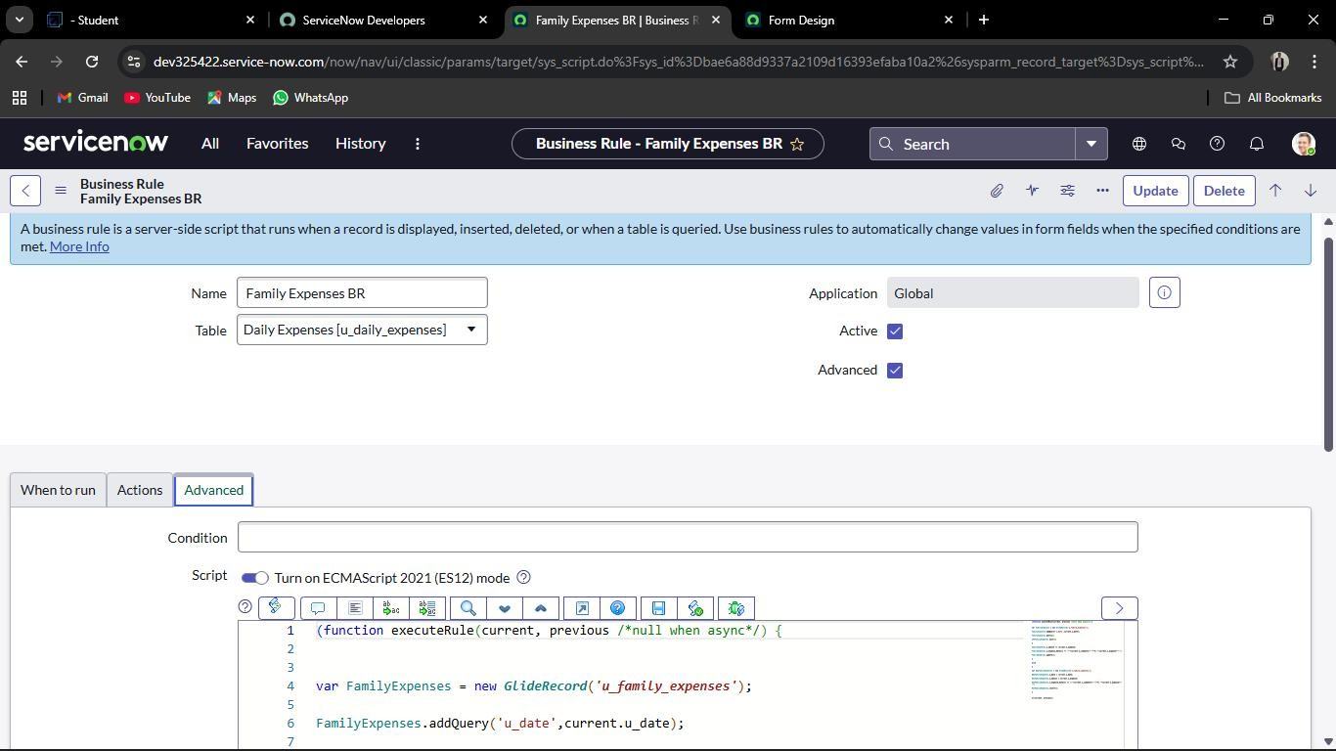

# MILSTONE8:CONFIGURETHE RELATIONSHIP

* NavigatetoAll>Relationshipsusingthefilternavigator.
* OpentheexistingDailyExpensesRelationship.
* Updatethedetailsasfollows:
  + AppliestoTable:*FamilyExpenses*
* IntheQuerywith section,enterthefollowingscript: (function refineQuery(current, parent) {

//Addyourcodehere,suchascurrent.addQuery(field,value); current.addQuery('u_date', parent.u_date); current.query();

})(current,parent); ClickUpdatetosavethe configuration

# CONCLUTION

The Family Expenses Management System built on ServiceNow demonstrates how the platform can be leveraged beyond IT workflows to solve real-world problems. By systematically creating tables, relationships, forms, and business rules, the project enables seamlesstrackingofbothdaily expenses and family-levelexpensesin an automated manner.

The use of auto-numbering, mandatory fields, related lists, and business rules ensures data integrity, consistency, and accuracy. The relationshipconfigurationfurtherenhancesvisibilitybylinkingdaily records to family-level summaries, providing a clear financial overview.

Through this project, we learned how to apply ServiceNow features suchastablecreation,formdesign,fieldconfiguration,scripting,and automation to build a complete application. More importantly, it highlights how low-code/no-code platforms like ServiceNow can be extended into personal finance, household management, and non-IT use cases.

Overall,theprojectprovidesa practical,scalable,anduser-friendly solution for managing family expenses efficiently while also strengthening skills in ServiceNow application development.